Group Project

Project Plan

Contents

- Introduction
  - Purpose of the Document
1.2 Scope
1.3 Objectives
- Overview
2.1 Platforms
2.2 High Level Architecture
- Use-cases
3.1 Use-case Diagram
3.2 Use Case Descriptions
3.2.1 Android Application
3.2.2 Website
- User interface design
4.1 Home Page
4.2 User Data Page(s)
4.3 Blank Record Page
4.4 Add Record Page
4.5 Record Page
4.6 Image Viewing Page
4.7 Side Menu
4.8 Explore Page
- Gantt chart
- Risk analysis
  - Personnel risks
  - Documentation Risks
  - Code Risks
  - Legend
- Document History

1 Introduction

Purpose of the Document
The purpose of this document is to show how we have interpreted the client’s specification, Reserve Plant Species Recording, into simple objective and milestones to be achieved.
The document is set out to define the interactions of the application and the overall appearance of the end user interface.
The document will also display a comprehensive Gantt chart displaying the project’s major tasks and milestones. As well as this there will be a risk analysis, which shall describe the main issues that could possibly be encountered throughout the development of the system and how these risks can be handled and or avoided.

Scope
The contents of this document should take into account the details of the group project specification.
The document includes the overview of the proposed system at hand, the choice of platforms to be used, a use case diagram entailing an overview of how the system will be expected to run, a description of the user interface design and end user interaction.
The document also includes a Gantt chart displaying start and end dates of tasks needed to complete the project. A risk analysis will also be available, displaying possible problems that may be encountered.

Objectives
The main objectives of this document are as to show all the different fields and aspects of the application

- To show a general sense of idea and the aspects of the application
- Record bugs and problems that has occurred and the solution
- Display how different component interact and behave with each other
- Provide criteria and standard the application must meet
- Record and provide milestones / achievements and progress

2 Overview
The proposed system is an Android based plant species recording application with an accompanying web interface, which both utilise a backend database stored on a server.

2.1 Platforms
- Android: the client specified an app written for the Android mobile operating system
- Java: as subject to the client’s specification for an Android app, Java is the language natively supported by Android.
- PHP: as per the client’s requirements, we will be building a website that interacts with the database. PHP is a good choice for this due to it being developed with web development in mind, so it is easier to code than other choices. Also, a significant number of members of our team are learning PHP as part of a different module.
- MySQL: MySQL is a widely supported database platform, which is free to use and acknowledged by many in the industry as one of the best free options.
- JavaScript: We will use JavaScript to ease the load on the server, and perform some simple tasks client-side (e.g. when editing a record, checking the data the user has entered is in the right format).

2.2 High Level Architecture
- Reserves: On the website, users will be able to enter and modify details about reserves (i.e. areas of nature users have visited and recorded plant species data at).
- Plant Species: The main requirement of this project is for users to be able to make records pertaining to plant species and their abundance. This will be the main functionality/screen of the application.
- Photos: A user can optionally attach a photo of the particular plant species and/or the surrounding area, for this we will use Android’s built-in Camera and/or Gallery.
- Reserve Records: On the website, users will be able to view plant species records logged at a specific reserve, we will be using SQL calls to selectively choose this data and displaying it to the user in an attractive and readable format.
- Target User: As per the requirements specification, the target user for this application will be naturalists familiar with standard computer interfaces, and concerned particularly about accuracy of recordings. Using this knowledge, and common knowledge about mobile applications, we will strive to make our application simple and easy to use but with the flexibility to allow users to enter accurate data. People using this app will likely be outside, and of course be using their phone, so will not want to spend too long entering data into a confusing app.

3 Use-case

3.1 Use-case Diagram
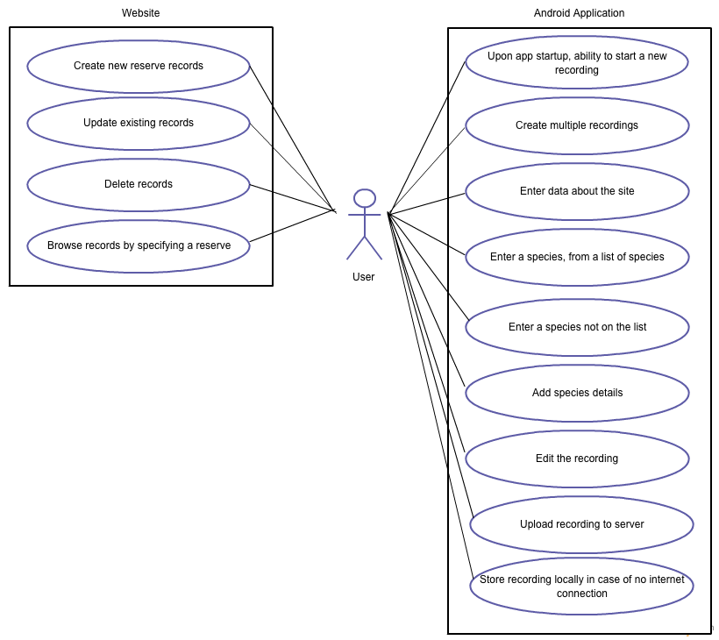

3.2 Use Case Descriptions

3.2.1 Android Application

Use Case | Description | Requirement
Create a recording | Upon opening the app, the user will be able to create a new recording | FR1
Create multiple recordings | The user will be able to create multiple recordings (for multiple species, or areas) | FR1
Enter data about the site | User will enter data about the site they are at (eg, a nature reserve) | FR2
Enter a species | User will enter a species from a list of plant species provided by Botanical Society of Britain and Ireland (“BSBI List 2007”) | FR3
Enter a species not on the list | If the species the user has seen is not on this list, they will be able to provide a name for the species recorded | FR3
Add species details | User will add details about the species: abundance of species (using the DAFOR scale), location, and optionally a photo and a comment | FR4
Edit the recording | User will be able to edit their recordings, either by changing the details or deleting the recording. | FR5
Upload recording to server | User will be able to upload their recording to the server, which will in turn add it to the database. | FR6
Store recording locally | If an internet connection is not available, the user will have the option to store the recording locally (and upload it later when a connection is available). | (none)

3.2.2 Website

Use Case | Description | Requirement
Create recordings | User will be able to create new reserve records through the website (with a name, location and description. | FR8
Update existing recordings | User will be able to update information stored in existing records. | FR8
Delete recordings | User will be able to delete records. | FR8
Browse records | User will be able to search for a reserve and browse species recordings taken at that location. | FR9

4 User interface design
4.1 Home Page
This is the page the user will see as soon as they open the app giving them two options. The “Record” button will take them to the “User Data Page”, whilst the “Explore” button will take them to the “Explore Page”.
It is important that this page is aesthetically pleasing, and intuitive to navigate to give a positive first impression of the app. If it is decided in the future that the guest area is not needed then the “Explore” button can be deleted and the “Record” button centered.
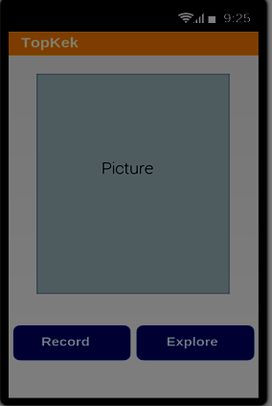

4.2 User Data Page(s)
These are two designs for the personal details page, they allow for the user to put in their details on the corresponding lines. If the user has their GPS enabled then the design on the left should be shown, with the map showing the users position. If the GPS is disabled then the design on the right should be shown with a drop down list of all possible nature reserves. Pressing start will bring up the “Blank Record Page”.

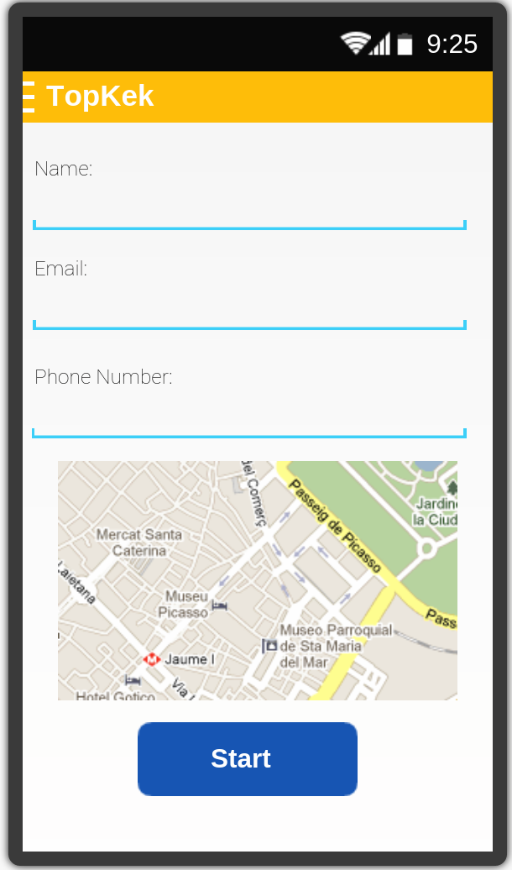

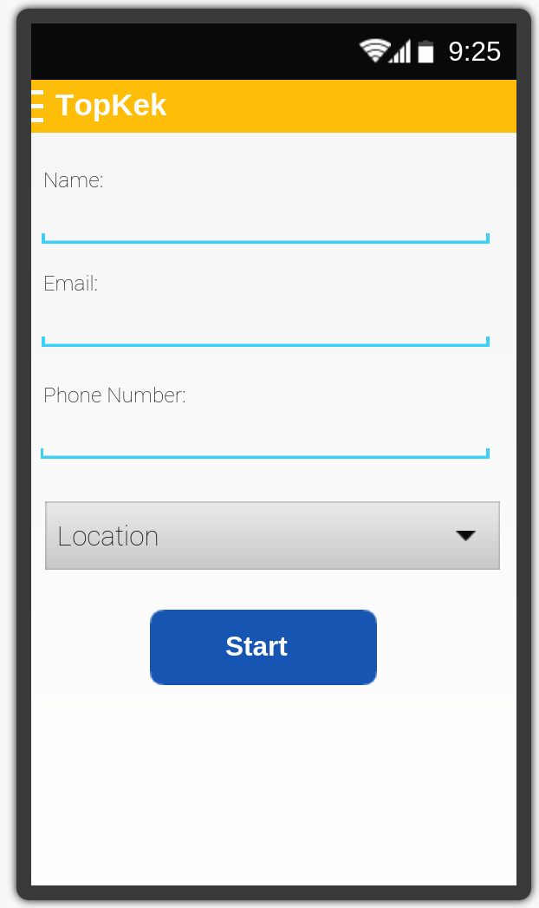

4.3 Blank Record Page
This page will display after the user has entered their details. It is a blank record page with a simple graphic displaying how to add a record.
This page should only be seen whilst no records have been added. Clicking the “+” in the top right corner will take the user to the “Add Record Page”.
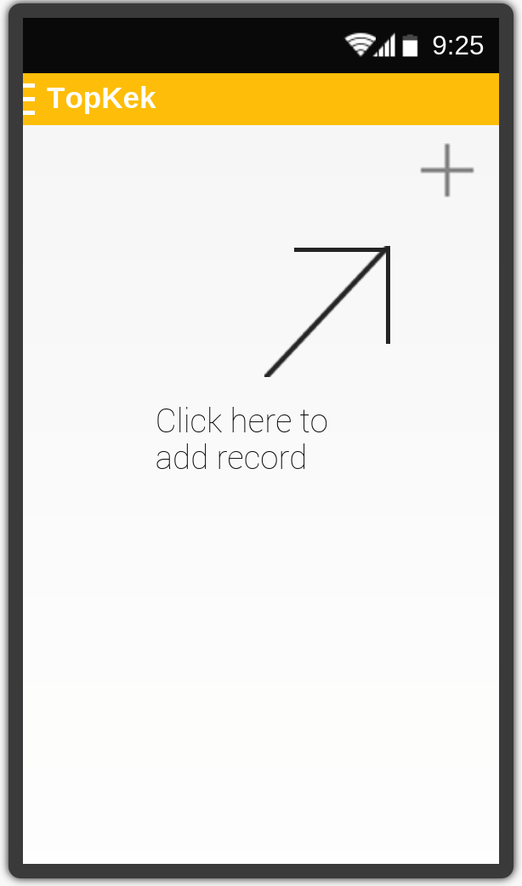

4.4 Add Record Page
This page will allow the user to add a record, it is pretty intuitive to use, the user must simply fill in the fields for the species that they are currently recording.
Towards the bottom of the form you can add a picture of the species or / and the surrounding location. Both the symbols that link you to do this are placeholder images. The current blue dot will allow the user to activate their camera and take a picture to add to the form, whilst the download symbol will allow the user to add a picture from their current gallery to the form.
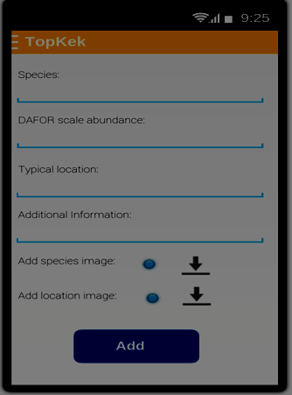
Upon completion of the form, clicking the “Add” button will take the user to the record page with the newly filled out record on display.

4.5 Record Page
This is the page that allows the user to navigate between all of their previously added records by swiping to either side.
Clicking the “+” in the top corner will allow the user to add a new record.
Clicking on the “hamburger” in the top left corner next to the place holder logo you will be able to select “Edit” which will take you to the Add Record page where the fields will already be filled with the previous information.
By clicking on the arrows in the picture the user can cycle through all of their current images for that specific species record, and then by pressing the image they bring up a new page which gives them a closer look at the pictures.
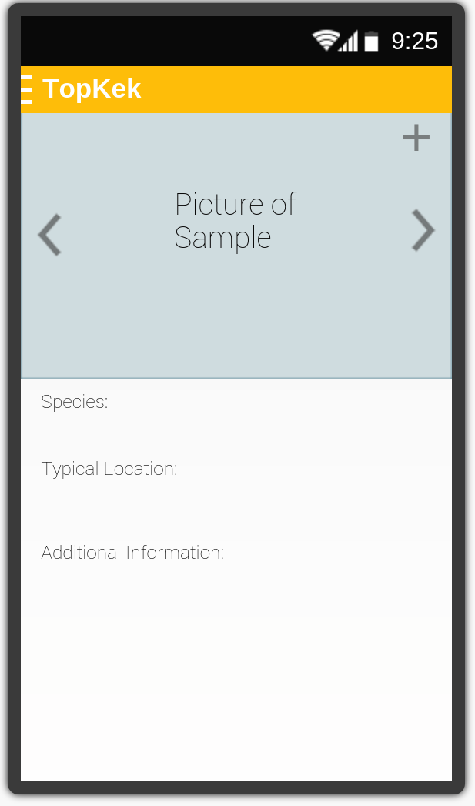

4.6 Image Viewing Page
In this page the user can swipe through all of their images for a specific species. This page has no functional use however, and so therefore is expendable.
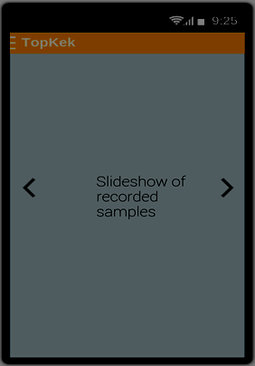

4.7 Side Menu
This image illustrates the menu which appears when the user clicks the “hamburger” in the top left corner. This menu should appear on all pages except the “Home Page”.
Then “Send” option will send the record information to the server database. This option should only be visible from the “Record Page”.
The “Edit” option will allow the user to edit previously input records. This option should only be visible from the “Record Page”.
The “Delete” option will allow the user to delete records. This option should only be visible from the “Record Page”.
The “Back” option will take the user to the previous page. This option should be visible from all pages excluding the “Home Page”.
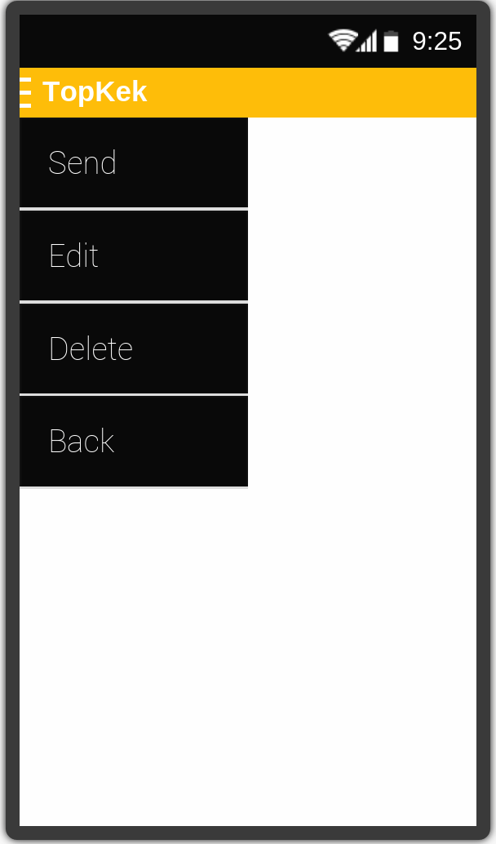

4.8 Explore Page
This page is navigated to using the “Explore” button on the “Home Page”. The page allows people to see a selection of previous community records without having to add any of their own. Records cannot be added or removed from this page.
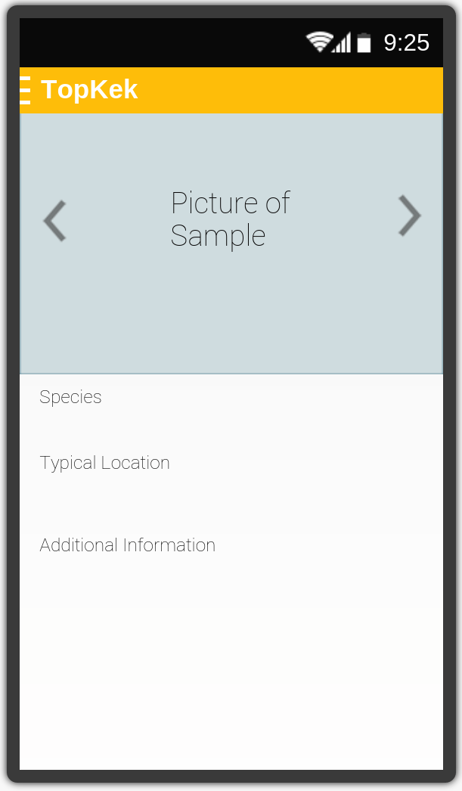

5 Gantt chart
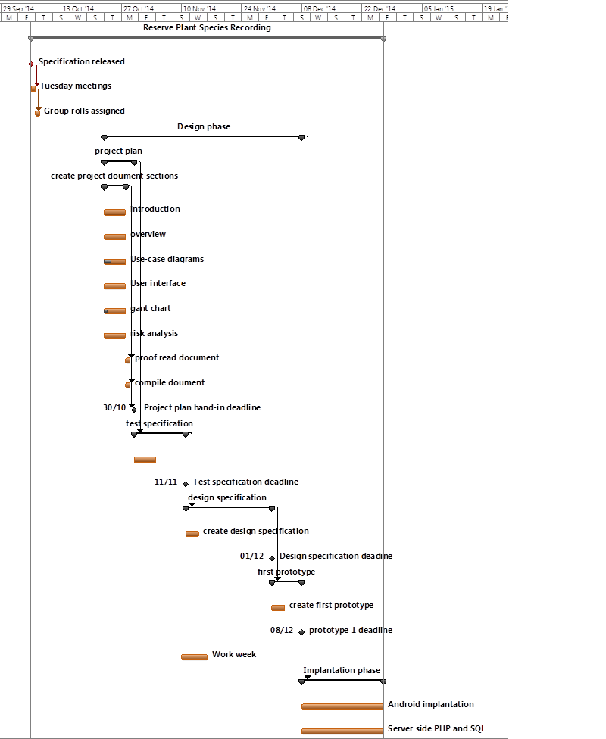
6 Risk analysis

6.1 Personnel risks
Risk Event | Risk Level | Prevention Methods | Alternative Procedure
People abandon project or become ill. | Medium | Discuss with team the repercussions of abandoning the project and the correct way to alert the team to any illnesses or sudden absences. | Delegate work to other members of the team.
Unable to meet deadlines. | Medium | Make and keep to the project schedule. | Enquire about extensions for the particular deadline.
Lack of knowledge on necessary topics. | Low | Do more research on topic. | Utilize team members correctly.
Human Error. | High | Team members proof-read each other’s work. | Test all work to stamp out mistakes.
Implementation does not work as expected by client. | Low | Keep to the specification. | Change the project as necessary.
Requirement change. | Low | Keep in regular contact with the client, to be prepared for changes. | Change work to fit the new requirements.
Shortage of personnel on particular tasks. | Medium | Ensure team availability. | Assign more members to a tasks possibly postponing others until the urgent task is complete.
Disagreement between team members or lack of collaboration. | Medium | Ensure the team members know how the implementation of the project will be carried out and with what tools, this removes the need for disagreements. | Discuss with management the best course of disciplinary action.
Failure in commitment. | Medium | Ensure the team understands there are repercussions for failing to commit to the project. | Disciplinary action.
Failure in management. | Low | Discuss with the group leader about worries over their management style and how they may be improved. | Disciplinary action. If such failure continues, suggest a change in leadership.
6.2 Documentation Risks

Risk Event | Risk Level | Prevention Method | Alternative procedure
Documentation late or of poor quality. | Low | Team members to proof-read each other’s work to ensure high quality in all documentation. | Re-submit any documentation that is not to the specifications standard.
Lack of analysis. | Low | Plan all steps of the project in detail allowing large spaces of time to be dedicated to analysis. | Arrange a group meeting specifically for analysis and design so we may step back and look at the specification again.
Unrealistic schedule. | High | Make the schedule as a team so we all agree on the time slots and how long tasks will take. | Meet as a team to re-design the schedule to a more realistic standard.
Poor definition of requirements. | Medium | Remain in regular contact with the client to get a better understanding on what the client is asking for. | Gain constant feedback on work from the client so any changes necessary can be carried out as soon as possible.

6.3 Code Risks

Risk event | Risk level | Prevention method | Alternative procedure
Repository failure. | Low | Back up all work to private machines. | Continue work from a backed up copy.
Parts of implementation missing or incomplete. | Medium | Team members should proof-read each other’s code before submission. | Complete or re-create code and the re-submit.
Lack of testing. | High | Create a testing schedule that the whole team is happy with to ensure enough testing. | Create and complete more tests.
Hardware does not work well. | Medium | Ensure hardware meets specified requirements before use. | Use university facilities in place of lesser machines.

6.4 Legend

Risk Level | Colour | Meaning
Low |  | This is unlikely to be an issue or will be minimal interruption to project events and tasks.
Medium |  | Possibility of occurring and may cause significant interruption of project tasks.
High |  | Likely to occur and should be the main risks focussed on by the group to prevent.

7 Document History

Version | Date | Changes made | Changed by
1.0 | 26/10/14 | Added front page, table of contents, and introduction | Jap55, cac36
2.0 | 27/10/14 | Added Gantt Chart | Jap55
3.0 | 27/10/14 | Added Risk Assessment | Jap55
4.0 | 27/10/14 | Added Use-Case | Jap55
5.0 | 27/10/14 | Added User Interface Design | Jap55
6.0 | 27/10/14 | Added Overview | Jap55
7.0 | 27/10/14 | Updated table of contents | Jap55

